**Title: Creating a Sponsored Video for Instagram**

**Table of Contents**

1. Executive Summary
2. Introduction
3. Planning and Strategy 3.1. Identifying the Brand and Objectives 3.2. Understanding the Target Audience 3.3. Content Creation
4. Production 4.1. Pre-production 4.2. Filming and Editing
5. Promotion 5.1. Hashtags and Captions 5.2. Scheduling and Timing 5.3. Collaborations
6. Measuring Success 6.1. Key Performance Indicators 6.2. Analytics and Insights
7. Conclusion

**1. Executive Summary**

This report details the process of creating a sponsored video for Instagram, a popular platform for influencer marketing and digital advertising. To maximize the effectiveness of sponsored videos, it's crucial to carefully plan, produce, and promote the content. The report outlines each step involved in creating a successful sponsored video, from identifying brand objectives to measuring the video's success.

**2. Introduction**

Sponsored videos on Instagram are a powerful marketing tool that allows brands to tap into the platform's vast user base. Instagram's visually engaging format makes it an ideal medium for promoting products or services. To create a sponsored video, one must follow a well-structured approach to ensure the content resonates with the target audience, aligns with brand goals, and achieves measurable results.

**3. Planning and Strategy**

Successful sponsored videos start with a solid plan and strategy. The following are essential components

**3.1. Identifying the Brand and Objectives**

Determine the brand's identity, mission, and specific campaign objectives. This includes understanding what the brand wants to achieve with the sponsored video, such as brand awareness, lead generation, or direct sales.



**3.2. Understanding the Target Audience**

Know your audience. Create buyer personas and segment the audience based on demographics, interests, and behavior. Tailor your content to their preferences.



**3.3. Content Creation**

Develop a concept that aligns with the brand's message and audience interests. The video should tell a compelling story, solve a problem, or entertain the viewers. Ensure the content is original, visually appealing, and engaging.

**4. Production**

The production phase involves bringing your content to life.

**4.1. Pre-production**

* Scripting: Develop a script or outline that details the video's structure, dialogue, and key points.
* Location and Equipment: Choose filming locations and secure the necessary equipment, including cameras, lighting, and sound.
* Talent and Crew: Identify on-screen talent or spokesperson, and assemble any necessary crew members.
* Legalities: Ensure all necessary legal agreements, such as contracts and releases, are in place.
* 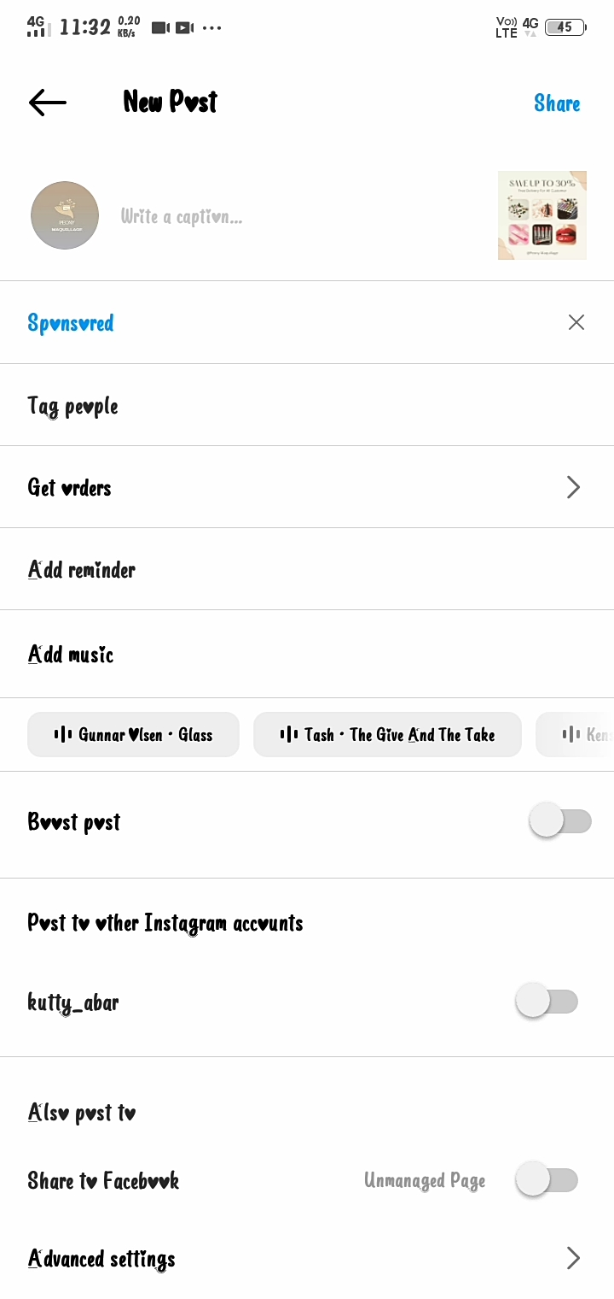

**4.2. Filming and Editing**

* Filming: Capture high-quality footage, keeping in mind the brand's messaging and the needs of the target audience.
* Editing: Edit the video, adding visual effects, music, and subtitles if necessary. Ensure the video's length is suitable for Instagram.
* 

**5. Promotion**

After creating the sponsored video, effective promotion is essential to reach a wide audience.

**5.1. Hashtags and Captions**

Use relevant and trending hashtags to increase discoverability. Craft engaging captions that provide context and encourage engagement.

**5.2. Scheduling and Timing**

Post the video at a time when the target audience is most active on the platform. Consider using Instagram's scheduling features to automate posts.

**5.3. Collaborations**

Collaborate with influencers or other Instagram users with a similar target audience to extend your video's reach.

**6. Measuring Success**

To evaluate the effectiveness of the sponsored video, track key performance indicators (KPIs) and analyze data.

**6.1. Key Performance Indicators**

Common KPIs include engagement metrics (likes, comments, shares), reach, click-through rates, and conversions (if applicable).

**6.2. Analytics and Insights**

Leverage Instagram's built-in analytics tools to gain insights into the video's performance. Monitor metrics over time to understand trends and make data-driven decisions for future campaigns.

**7. Conclusion**

Creating a sponsored video for Instagram is a multi-faceted process that involves careful planning, production, and promotion. By understanding brand objectives, identifying the target audience, and crafting engaging content, you can create a successful sponsored video. Regularly analyze performance metrics to fine-tune your strategy and continuously improve future campaigns. With the right approach, Instagram's vast user base can be a valuable asset for brand promotion.

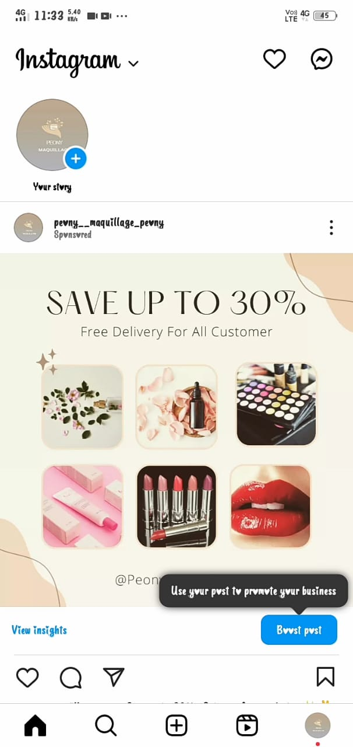

Top of Form